**ASSIGNMENT NO.1.**

**Aim :-**To create ADT that implement the "set" concept.

a. Add (newElement) -Place a value into the set

b. Remove (element)

c. Contains (element) Return true if element is in collection

d. Size () Return number of values in collection

e. Intersection of two sets

f. Union of two sets

g. Difference between two sets h.Subset .

**Objective:-** to study the different set operations. To get the thorough understanding of the concepts of sets and the various operations performed on it.

**Theory:-**

**Set** is a container implemented in C++ language in STL and has a concept similar to how set is defined in mathematics. The facts that separates set from the other containers is that is it contains only the **distinct elements**and elements can be traversed in sorted order. Having the strong hold on sets is useful in competitive programming and solving algorithmic problems. The insertion and deletion in STL sets are discussed in this article.Sets have the most impact in mathematical set theory. These theories are used in many kinds of proofs, structures, and abstract algebra. Creating relations from different sets and codomains are also an important applications of sets.

In computer science, set theory is useful if you need to collect data and do not care about their multiplcity or their order. In databases, especially for relational databases, sets are very useful. There are many commands that finds unions, intersections, and differences of different tables and sets of data.

EQUAL SETS-

Two sets are said to be equal if both have same elements. For example A = {1, 3, 9, 7} and B = {3, 1, 7, 9} are equal sets. SUBSET:-• A set A is said to be subset of another set B if and only if every element of set A is also a part of other set B. Denoted by ‘⊆‘. ‘A ⊆ B ‘ denotes A is a subset of B.

SIZE OF A SET:-

Size of a set can be finite or infinite. Size of the set S is known as Cardinality number, denoted as |S|. Example: Let A be a set of odd positive integers less than 10. Solution : A = {1,3,5,7,9}, Cardinality of the set is 5, i.e.,|A| = 5.

UNION :•

Union of the sets A and B, denoted by A ∪ B, is the set of distinct element belongs to set A or set B, or both.

INTERSECTION:• The intersection of the sets A and B, denoted by A ∩ B, is the set of elements belongs to both A and B i.e. set of the common element in A and B SET

DIFFERENCE:-•

Difference between sets is denoted by ‘A – B’, is the set containing elements of set A but not in B. i.e all elements of A except the element of B.

***ALGORITHM:***

FOR INTERSECTION:•

Step 1: Take an empty set (intersection set) Step 2: pass each element of set-2 and the entire set-1 to the function member() Step 3:if it returns true, Add that element to the intersection set FOR

UNION:•

Step 1: Take an empty set (union set)

Step 2: copy all the elements of set1 to this new set

Step 3: traverse through the set2 and pass each element of set-2 along with the entire set-1 to the function member(), and if it returns false then add that specified element to the union set

FOR CONTAINS:•

Step1 : take the number as input which you want to search

Step 2 : enter 1 for searching in set-1 or 2 for searching in set-2

Step 3 : initialise i=0

Step 4: traverse the set-1 or set-2 till the end depending on whether the input was 1 or 2 after passing the element and that set to the function member()

Step 5: if element found then display element is present C Department of Computer

4 FOR SUBSET:•

Step 1: enter 1 if you want to check if set 2 is subset of 1, or enter 2 if you want to check if set-1 is subset of set-2

Step 2: depending on input we will traverse the set(which has to be the subset) until its end, by passing each element of this set and other set to the function member()

Step 3: if member() returns true, then continue else return false

Step 4: if false, then display “it is a subset” else display “it is not”

FOR DIFFERENCE :•

Step 1: Initialise the difference set to 0, difference set contains all the element which are in set-1 but not in set-2

Step 2: traverse the entire set-1 and, pass each element of this set and the the set-2 to the function member()

Step 3: if it returns false then add this element to the difference set

FOR REMOVE:•

Step 1: enter 1 or 2 for removing element from set-1 or set-2 respectively

Step 2: enter the index from which you want to remove the element

Step 3: if , entered position is less than the size of the set then move all the elements to their left from the position at which you want to remove the element and just decrease the size of the set else, entered position is equal to the size of the set then just decrease the size

FOR SIZE:•

step 1: show the 0th index of the set which contains the size of our set

**Program Code:-**

#include <iostream>

using namespace std;

const int MAX=50;

template<class T>

class SET

{

T data[MAX];

int n;

public:

SET()

{

n=-1;

}

bool insert(T);

bool remove(T);

bool contains(T);

int size();

void print();

void input(int num);

SET unionS(SET,SET);

SET intersection(SET,SET);

SET difference(SET,SET);

};

template<class T>

void SET<T>::input(int num)

{

T element;

for(int i=0;i<num;i++)

{

cout<<"\nEnter Element: "<<i+1;

cin>>element;

insert(element);

}

}

template<class T>

void SET<T>::print()

{

for(int i=0;i<=n;i++)

cout<<" "<<data[i];

}

template<class T>

SET<T> SET<T>::unionS(SET<T> s1,SET<T> s2)

{

SET<T> s3;

int flag=0;

int i=0;

for(i=0;i<=s1.n;i++)

{

s3.insert(s1.data[i]);

}

for(int j=0;j<=s2.n;j++)

{

flag=0;

for(i=0;i<=s1.n;i++)

{

if(s1.data[i]==s2.data[j])

{

flag=1;

break;

}

}

if(flag==0)

{

s3.insert(s2.data[j]);

}

}

return s3;

}

template<class T>

SET<T> SET<T>::difference(SET<T> s1,SET<T> s2)

{

SET<T> s3;

int flag=1;

for(int i=0;i<=s1.n;i++)

{

for(int j=0;j<=s2.n;j++)

{

if(s1.data[i]==s2.data[j])

{

flag=0;

break;

}

else flag=1;

}

if(flag==1)

{

s3.insert(s1.data[i]);

}

}

return s3;

}

template<class T>

SET<T> SET<T>::intersection(SET<T> s1,SET<T> s2)

{

SET<T> s3;

for(int i=0;i<=s1.n;i++)

{

for(int j=0;j<=s2.n;j++)

{

if(s1.data[i]==s2.data[j])

{

s3.insert(s1.data[i]);

break;

}

}

}

return s3;

}

template<class T>

bool SET<T>::insert(T element)

{

if(n>=MAX)

{

cout<<"\nOverflow.SET is full.\n";

return false;

}

data[++n]=element;

return true;

}

template<class T>

bool SET<T>::remove(T element)

{

if(n==-1)

{

cout<<"Underflow. Cannot perform delete operation on empty SET.";

return false;

}

for(int i=0;i<=n;i++)

{

if(data[i]==element)

{

for(int j=i;i<=n;j++)

{

data[j]=data[j+1];

}

return true;

}

}

//data[n--]=0;

return false;

}

template<class T>

bool SET<T>::contains(T element)

{

for(int i=0;i<=n;i++)

{

if(data[i]==element)

return true;

}

return false;

}

template<class T>

int SET<T>::size()

{

return n+1;

}

int main() {

SET<int> s1,s2,s3;

int choice;

int element;

cout<<"\nEnter number of elements in SET1:";

cin>>element;//element is used for taking size

s1.input(element);

cout<<"\nEnter number of elements in SET2:";

cin>>element;//element is used for taking size

s2.input(element);

do

{

cout<<"\n\*\*\*\*\* SET OPERATIONS \*\*\*\*\*"

<<"\n1.Insert"

<<"\n2.Remove"

<<"\n3.Search"

<<"\n4.Size of Set"

<<"\n5.Intersection"

<<"\n6.Union"

<<"\n7.Difference"

<<"\n8.Check if Subset"

<<"\nEnter Your Choice: ";

cin>>choice;

switch(choice)

{

case 1:

cout<<"\nEnter Element: ";

cin>>element;

if(s1.insert(element))

{

cout<<element<<" inserted";

}

else

{

cout<<"Insertion Failed";

}

break;

case 2:

cout<<"\nEnter Element: ";

cin>>element;

if(s1.remove(element))

{

cout<<element<<" deleted";

}

else

{

cout<<"Deletion Failed";

}

break;

case 3:

cout<<"\nEnter Element: ";

cin>>element;

if(s1.contains(element))

{

cout<<element<<" is present";

}

else

{

cout<<element<<"is not Present";

}

break;

case 4:

cout<<"\nSize = "<<s1.size();

break;

case 5:

s3=s1.intersection(s1,s2);

cout<<"\nSET 1's elements: ";

s1.print();

cout<<"\nSET 2's elements: ";

s2.print();

cout<<"\nIntersection: :";

s3.print();

break;

case 6:

s3=s1.unionS(s1,s2);

cout<<"\nSET 1's elements: ";

s1.print();

cout<<"\nSET 2's elements: ";

s2.print();

cout<<"\nUnion :";

s3.print();

break;

case 7:

s3=s1.difference(s1,s2);

cout<<"\nSET 1's elements: ";

s1.print();

cout<<"\nSET 2's elements: ";

s2.print();

cout<<"\nDifference :";

s3.print();

break;

}

}while(choice!=0);

return 0;

}

**Output Screenshots:-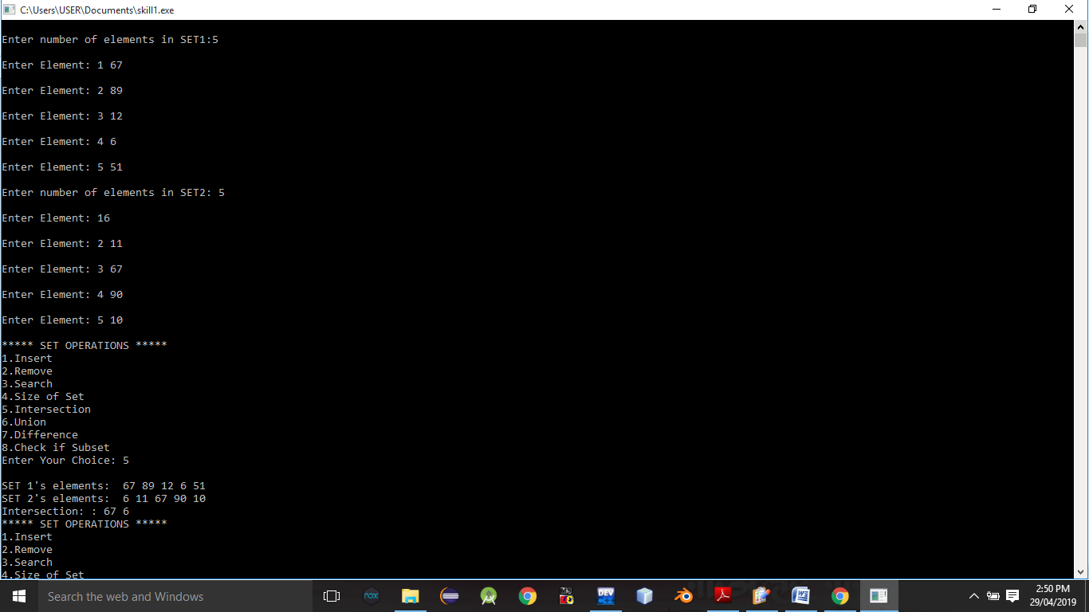**

**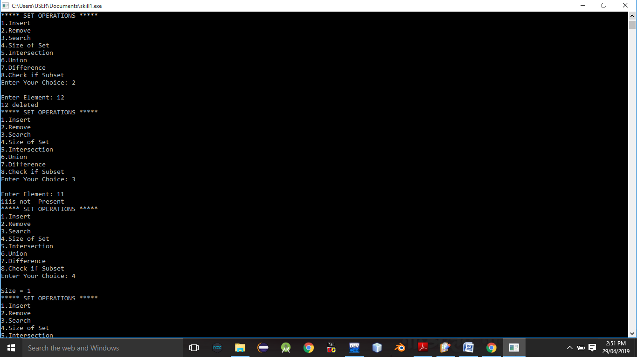**

Conclusion:-

Thus,we have studied different operations on set ADT.

**ASSIGNMENT NO.2.**

**Aim :-**

Construct a threaded binary search tree by inserting values in the given order and traverse it in inorder traversal using threads.

**Objective:-**

To understand the following Concepts of Threaded Binary Search Tree (TBT):

i. Creating a TBT using tree data structure

. ii. Inorder traversal using threads.

**Theory:-**

A [binary tree](https://www.includehelp.com/data-structure-tutorial/binary-tree-definition-and-its-properties.aspx) can be represented by using array representation or linked list representation. When a binary tree is represented using linked list representation. If any node is not having a child we use a NULL pointer. These special pointers are threaded and the binary tree having such pointers is called a threaded binary tree. Thread in a binary tree is represented by a dotted line. In linked list representation of a binary tree, they are a number of a NULL pointer than actual pointers. This NULL pointer does not play any role except indicating there is no child. The **threaded binary tree** is proposed by A.J Perlis and C Thornton. There are three ways to thread a binary tree.

1. In the in order traversal When The right NULL pointer of each leaf node can be replaced by a thread to the successor of that node then it is called a right thread, and the resultant tree called a right threaded tree or right threaded binary tree.
2. When The left NULL pointer of each node can be replaced by a thread to the predecessor of that node under in order traversal it is called left thread and the resultant tree will call a left threaded tree.
3. In the in order traversal, the left and the right NULL pointer can be used to point to predecessor and successor of that node respectively. then the resultant tree is called a fully threaded tree.

In the threaded binary tree when there is only one thread is used then it is called as one way threaded tree and when both the threads are used then it is called the two way threaded tree. The pointer point to the root node when If there is no in-order predecessor or in-order successor.

Following diagram shows an example Single Threaded Binary Tree. The dotted lines represent threads.  
[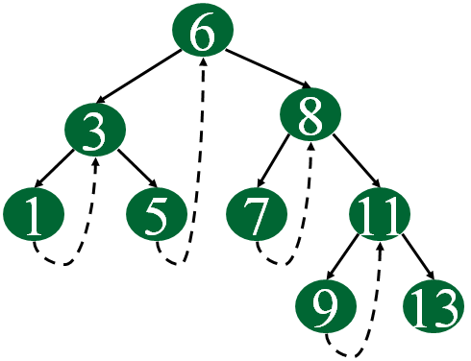](https://www.geeksforgeeks.org/wp-content/uploads/gq/2014/07/threadedBT.png)

**Algorithm:-**

Let **tmp be the newly inserted node**. There can be three cases during insertion:

**Case 1: Insertion in empty tree**  
Both left and right pointers of tmp will be set to NULL and new node becomes the root.

root = tmp;

tmp -> left = NULL;

tmp -> right = NULL;

**Case 2: When new node inserted as the left child**  
After inserting the node at its proper place we have to make its left and right threads points to inorder predecessor and successor respectively. The node which was [inorder successor](https://www.geeksforgeeks.org/inorder-successor-in-binary-search-tree/). So the left and right threads of the new node will be-

tmp -> left = par ->left;

tmp -> right = par;

Before insertion, the left pointer of parent was a thread, but after insertion it will be a link pointing to the new node.

par ->lthread = false;

par -> left = temp;

Following example show a node being inserted as left child of its parent.  
https://cdncontribute.geeksforgeeks.org/wp-content/uploads/threadbinarytree.png  
After insertion of 13,  
https://cdncontribute.geeksforgeeks.org/wp-content/uploads/tbt13inserted.png  
Predecessor of 14 becomes the predecessor of 13, so left thread of 13 points to 10.  
Successor of 13 is 14, so right thread of 13 points to left child which is 13.  
Left pointer of 14 is not a thread now, it points to left child which is 13.

**Case 3: When new node is inserted as the right child**  
The parent of tmp is its inorder predecessor. The node which was inorder successor of the parent is now the inorder successor of this node tmp. So the left and right threads of the new node will be-

tmp -> left = par;

tmp -> right = par -> right;

Before insertion, the right pointer of parent was a thread, but after insertion it will be a link pointing to the new node.

par ->rthread = false;

par -> right = tmp;

**Program Code:-**

#include <iostream>

using namespace std;

class TBT;

class node

{

node \*left,\*right;

int data;

boolrbit,lbit;

public:

node()

{

left=NULL;

right=NULL;

rbit=lbit=0;

}

node(int d)

{

left=NULL;

right=NULL;

rbit=lbit=0;

data=d;

}

friend class TBT;

};

class TBT

{

node \*root; //acts as a dummy node

public:

TBT() //dummy node initialization

{

root=new node(9999);

root->left=root;

root->rbit=1;

root->lbit=0;

root->right=root;

}

void create();

void insert(int data);

node \*inorder\_suc(node \*);

voidinorder\_traversal();

node \* preorder\_suc(node \*c);

voidpreorder\_traversal();

};

//--------------------------------------------

void TBT::preorder\_traversal()

{

node \*c=root->left;

while(c!=root)

{

cout<<" "<<c->data;

c=preorder\_suc(c);

}

}

void TBT::inorder\_traversal()

{

node \*c=root->left;

while(c->lbit==1)

c=c->left;

while(c!=root)

{

cout<<" "<<c->data;

c=inorder\_suc(c);

}

}

node\* TBT::inorder\_suc(node \*c)

{

if(c->rbit==0)

return c->right;

else

c=c->right;

while(c->lbit==1)

{

c=c->left;

}

return c;

}

node \*TBT::preorder\_suc(node \*c)

{

if(c->lbit==1)

{

return c->left;

}

while(c->rbit==0)

{

c=c->right;

}

return c->right;

}

//-------- Create Method

void TBT::create()

{

int n;

if(root->left==root&&root->right==root)

{

cout<<"\nEnter number of nodes:";

cin>>n;

for(inti=0;i<n;i++)

{

int info;

cout<<"\nEnter data: ";

cin>>info;

this->insert(info);

}

}

else

{

cout<<"\nTree is Already created.\n";

}

}

void TBT::insert(int data)

{

if(root->left==root&&root->right==root) //no node in tree

{

node \*p=new node(data);

p->left=root->left;

p->lbit=root->lbit; //0

p->rbit=0;

p->right=root->right;

root->left=p;

root->lbit=1;

cout<<"\nInserted start"<<data;

return;

}

node \*cur=new node;

cur=root->left;

while(1)

{

if(cur->data<data) //insert right

{

node \*p=new node(data);

if(cur->rbit==0)

{

p->right=cur->right;

p->rbit=cur->rbit;

p->lbit=0;

p->left=cur;

cur->rbit=1;

cur->right=p;

//cout<<"\nInserted right "<<data;

cout<< data<<" Inserted right"<<" of "<< cur->data<<endl;

return;

}

else

cur=cur->right;

}

if(cur->data>data) //insert left

{

node \*p=new node(data);

if(cur->lbit==0)

{

p->left=cur->left;

p->lbit=cur->lbit;

p->rbit=0;

p->right=cur; //successor

cur->lbit=1;

cur->left=p;

cout<<data <<" Inserted left "<<" of "<<cur->data<<endl;

return;

}

else

cur=cur->left;

}

}

}

int main() {

TBT t1;

int value;

int choice;

do

{

cout<<"\n1.Create Tree\n2.Insert into tree\n3.Preorder\n4.Inorder\n0.Exit\nEnter your choice: ";

cin>>choice;

switch(choice)

{

case 1:

t1.create();

break;

case 2:

cout<<"\nEnter Number(data): ";

cin>>value;

t1.insert(value);

break;

case 3:

cout<<"\nPreorder traversal of TBT\n";

t1.preorder\_traversal();

break;

case 4:

cout<<"\nInoder Traversal of TBT\n";

t1.inorder\_traversal();

break;

default:

cout<<"\nWrong choice";

}

}while(choice!=0);

return 0;

}

**Output Screenshots:-**

**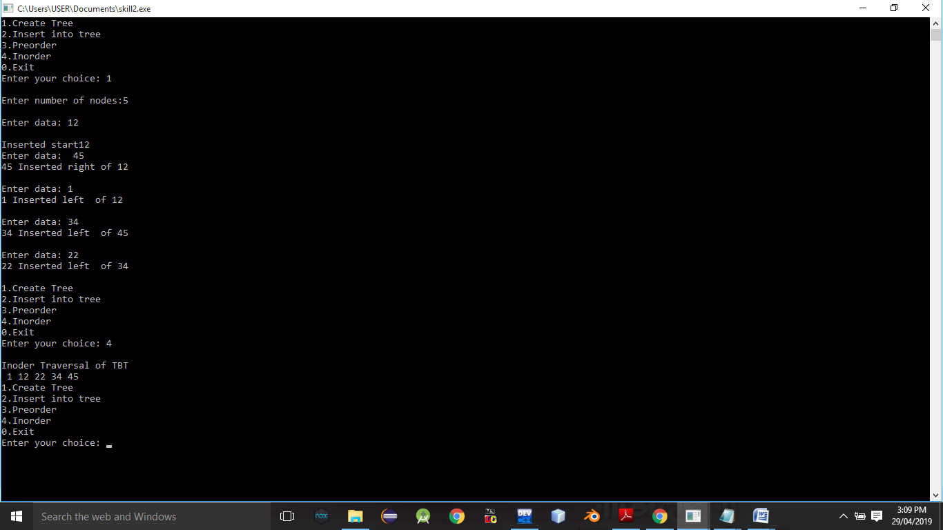**

**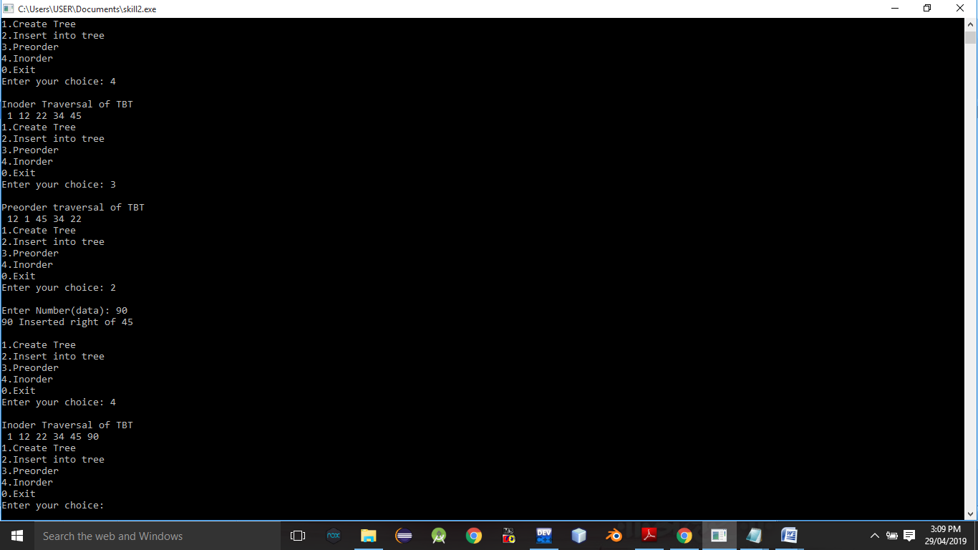**

**Conclusion:-**Thus,we have studied Threaded binary tree.

**ASSIGNMENT NO.3.**

**Aim :-**

There are flight paths between cities. If there is a flight between city A and city B then there is an edge between the cities. The cost of the edge can be the time that flight takes to reach city B from A, or the amount of fuel used for the journey. Represent this as a graph. The node can be represented by airport name or name of the city. Use adjacency list representation of the graph or use adjacency matrix representation of the graph. Justify the storage representations used .

**Objective:-** To learn adjacency list representation of graph.

**Theory:-**

Following two are the most commonly used representations of a graph.  
**1.** Adjacency Matrix  
**2.** Adjacency List  
There are other representations also like, Incidence Matrix and Incidence List. The choice of the graph representation is situation specific. It totally depends on the type of operations to be performed and ease of use.

**Adjacency Matrix:**  
Adjacency Matrix is a 2D array of size V x V where V is the number of vertices in a graph. Let the 2D array be adj[][], a slot adj[i][j] = 1 indicates that there is an edge from vertex i to vertex j. Adjacency matrix for undirected graph is always symmetric. Adjacency Matrix is also used to represent weighted graphs. If adj[i][j] = w, then there is an edge from vertex i to vertex j with weight w.

The adjacency matrix for the above example graph is:  
Adjacency Matrix Representation  
**Adjacency List:**  
An array of lists is used. Size of the array is equal to the number of vertices. Let the array be array[]. An entry array[i] represents the list of vertices adjacent to the***i***th vertex. This representation can also be used to represent a weighted graph. The weights of edges can be represented as lists of pairs. Following is adjacency list representation of the above graph.

**Algorithm:-**

**1.BFS :-**

* **Step 1:** SET STATUS = 1 (ready state)  
  for each node in G
* **Step 2:** Enqueue the starting node A  
  and set its STATUS = 2  
  (waiting state)
* **Step 3:** Repeat Steps 4 and 5 until  
  QUEUE is empty
* **Step 4:** Dequeue a node N. Process it  
  and set its STATUS = 3  
  (processed state).
* **Step 5:** Enqueue all the neighbours of  
  N that are in the ready state  
  (whose STATUS = 1) and set  
  their STATUS = 2  
  (waiting state)  
  [END OF LOOP]
* **Step 6:** EXIT

**2.DFS :-**

* **Step 1:** SET STATUS = 1 (ready state) for each node in G
* **Step 2:** Push the starting node A on the stack and set its STATUS = 2 (waiting state)
* **Step 3:** Repeat Steps 4 and 5 until STACK is empty
* **Step 4:** Pop the top node N. Process it and set its STATUS = 3 (processed state)
* **Step 5:** Push on the stack all the neighbours of N that are in the ready state (whose STATUS = 1) and set their  
  STATUS = 2 (waiting state)  
  [END OF LOOP]
* **Step 6:** EXIT

**Program Code:-**

#include <iostream>

#include<iomanip>

using namespace std;

const int MAX=30;

class Queue //Queue for BFS TRAVERSAL

{

int front,rear;

string data[MAX];

public:

Queue()

{

front=-1;

rear=-1;

}

bool empty()

{

if(rear==-1)

return 1;

else

return 0;

}

bool inqueue(string str)

{

if(front==-1 && rear==-1)

{

front=rear=0;

data[rear]=str;

return true;

}

else

{

rear=rear+1;

data[rear]=str;

return true;

}

}

string dequeue()

{

string p;

if(front==rear)

{

p=data[front];

front=-1;

rear=-1;

}

else

{

p=data[front];

front=front+1;

}

return p;

}

};

class node //node class for each airport

{

node \*next;

string city;

int timeCost;

public:

friend class graph;

node()

{

next=NULL;

city="";

timeCost=-1;

}

node(string city,int weight)

{

next=NULL;

this->city=city;

timeCost=weight;

}

};

class graph //Contains total graph of airports

{

node \*head[MAX];

int n;

int visited[MAX];

public:

graph(int num)

{

n=num;

for(int i=0;i<n;i++)

head[i]=NULL;

}

void insert(string city1,string city2,int time);

void insertUndirected(string city1,string city2,int time);

void readdata(int gType);

int getindex(string s1);

void outFlights();

void inFlights();

void DFS(string str);

void BFS();

void dfsTraversal();

};

void graph::BFS()

{

string str=head[0]->city;

int j;

//node \*p;

for(int i=0;i<n;i++)

visited[i]=0;

Queue queue;

queue.inqueue(str);

int i=getindex(str);

cout<<"BFS Traversal: \n";

cout<<" "<<str<<" ";

visited[i]=1;

while(!queue.empty())

{

string p=queue.dequeue();

i=getindex(p);

//visited[i]=1;

for(node \*q=head[i];q!=NULL;q=q->next)

{

i=getindex(q->city);

str=q->city;

if(!visited[i])

{

queue.inqueue(q->city);

visited[i]=1;

cout<<" "<<str<<" ";

}

}

}

cout<<"\n";

}

void graph::dfsTraversal()

{

for( int i=0;i<n;i++)

visited[i]=0;

cout<<"\nDFS TRAVERSAL: \n";

DFS(head[0]->city);

cout<<"\n";

}

void graph::DFS(string str)

{

node \*p;

int i=getindex(str);

cout<<" "<<str<<" ";

p=head[i];

visited[i]=1;

while(p!=NULL)

{

str=p->city;

i=getindex(str);

if(!visited[i])

DFS(str);

p=p->next;

}

}

void graph::inFlights()

{

int count[n];

for(int i=0;i<n;i++)

count[i]=0;

cout<<"====== In degree =========\n";

for(int i=0;i<n;i++)

{

cout<<"\n"<<setw(8)<<"Source"<<setw(8)<<"Destin."<<setw(8)<<"Time";

for(int j=0;j<n;j++)

{

node \*p=head[j]->next;

while(p!=NULL)

{

if(p->city==head[i]->city)

{

count[i]=count[i]+1;

cout<<"\n"<<setw(8)<<head[j]->city<<setw(8)<<head[i]->city<<setw(8)<<p->timeCost;

}

p=p->next;

}

}

cout<<"\nFlights to "<<head[i]->city<<" = "<<count[i]<<endl;

cout<<"-------------------------------------\n";

}

}

void graph::outFlights()

{

int count;

for(int i=0;i<n;i++)

{

node \*p=head[i]->next;

count=0;

cout<<"\n"<<setw(8)<<"Source"<<setw(8)<<"Destin."<<setw(8)<<"Time";

if(p==NULL)

{

cout<<"\nNo Flights from "<<head[i]->city;

}

else

{

while(p!=NULL)

{

cout<<"\n"<<setw(8)<<head[i]->city<<setw(8)<<p->city<<setw(8)<<p->timeCost;

count++;

p=p->next;

}

}

cout<<"\nNo. of flights: "<<count<<endl;;

cout<<"-------------------------------------\n";

}

}

int graph::getindex(string s1)

{

for(int i=0;i<n;i++)

{

if(head[i]->city==s1)

return i;

}

return -1;

}

void graph::insert(string city1,string city2,int time)

{

node \*source;

node \*dest=new node(city2,time);

int ind=getindex(city1); //for getting head nodes index in array

if(head[ind]==NULL)

head[ind]=dest;

else

{

source=head[ind];

while(source->next!=NULL)

source=source->next;

source->next=dest;

}

}

void graph::insertUndirected(string city1,string city2,int time)

{

node \*source;

node \*dest=new node(city2,time);

node \*dest2=new node(city1,time); //for second flight insertion

int ind=getindex(city1); //for getting head nodes index in array

int ind2=getindex(city2);

/\* if(head[ind]==NULL && head[ind2]==NULL) //when no flights in graph

{

head[ind]=dest;

head[ind2]=dest2;

}

else if(head[ind]==NULL && head[ind2]!=NULL) //no flight in first list but flight in second list

{

head[ind]=dest; //inserted first flight

source=head[ind2];

while(source->next!=NULL)

source=source->next;

source->next=dest2;

}

else if(head[ind]!=NULL && head[ind2]==NULL)

{

head[ind2]=dest2; //inserted first flight

source=head[ind];

while(source->next!=NULL)

source=source->next;

source->next=dest;

}

else

{\*/

source=head[ind];

while(source->next!=NULL)

source=source->next;

source->next=dest;

source=head[ind2];

while(source->next!=NULL)

source=source->next;

source->next=dest2;

//}

}

void graph::readdata(int gType)

{

string city1,city2,tmpcity;

int fcost;

int flight;

cout<<"\nENter City Details:\n ";

for(int i=0;i<n;i++)

{

head[i]=new node;

cout<<"Enter City "<<i+1<<" ";

cin>>tmpcity;

head[i]->city=tmpcity;

}

cout<<"\nEnter Number of Flights to insert: ";

cin>>flight;

if(gType==1)

{

for(int i=0;i<flight;i++)

{

cout<<"\nEnter Source:";

cin>>city1;

cout<<"Enter Destination:";

cin>>city2;

cout<<"Enter Time:";

cin>>fcost;

insert(city1,city2,fcost);

}

}

else

{

for(int i=0;i<flight;i++)

{

cout<<"\nEnter Source:";

cin>>city1;

cout<<"Enter Destination:";

cin>>city2;

cout<<"Enter Time:";

cin>>fcost;

insertUndirected(city1,city2,fcost);

//cout<<"\ninserted"<<i+1;

}

}

}

int main() {

int number,choice;

int graphype;

cout<<"-------INDIA AIRLINES PVT LTD--------"

<<"\n0. Undirected\n1.Directed\nEnter Flight data Insertion Type:";

cin>>graphype;

cout<<"\nENter Number of Airport Stations:";

cin>>number;

graph g1(number);

g1.readdata(graphype);

do

{

cout<<"-------- Menu --------"

<<"\n1.Incoming Flights(In degree)"

<<"\n2.Outgoing Flights(Out degree)"

<<"\n3.DFS"

<<"\n4.BFS"

<<"\n5.Exit"

<<"\nEnter your choice: ";

cin>>choice;

switch(choice)

{

case 1:

cout <<"" << endl;

g1.inFlights();

break;

case 2:

g1.outFlights();

break;

case 3:

g1.dfsTraversal();

break;

case 4:

g1.BFS();

break;

default:

cout<<"\nWrong Choice";

}

}while(choice!=5);

return 0;

}

**Output Screenshots:-**

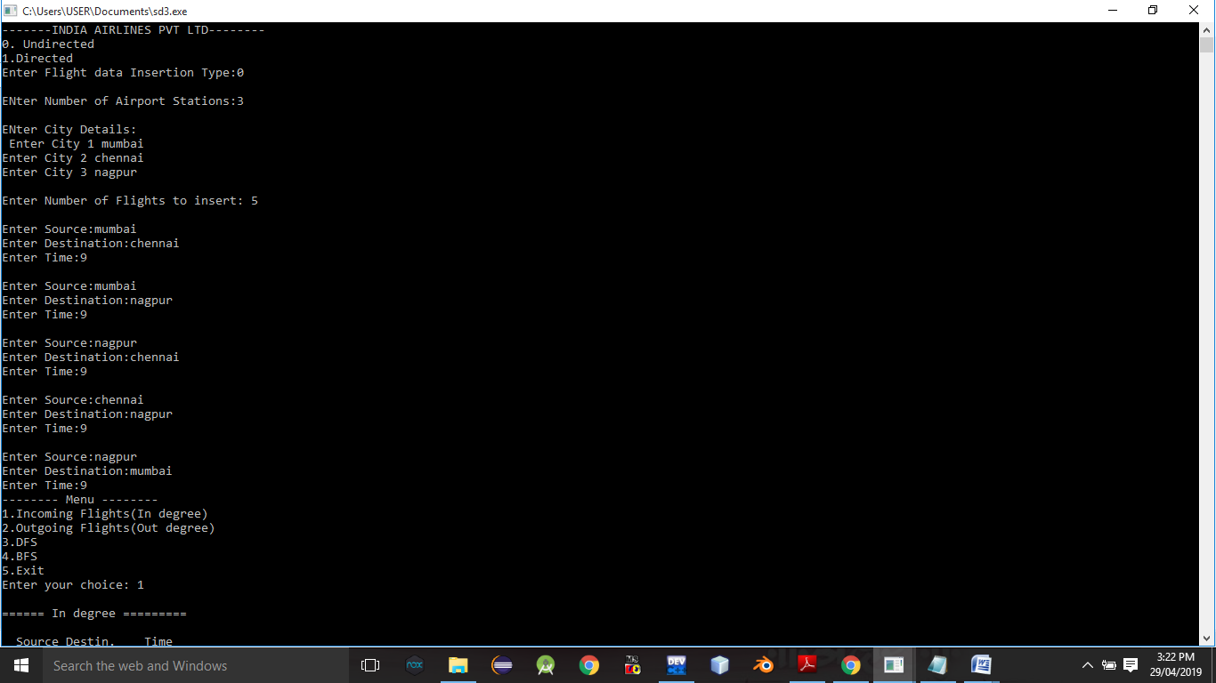

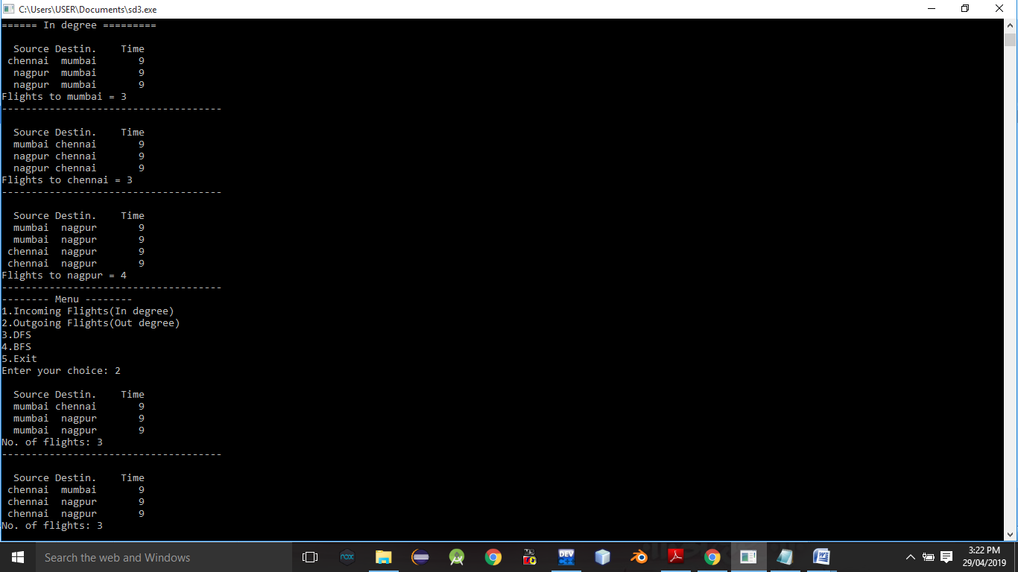

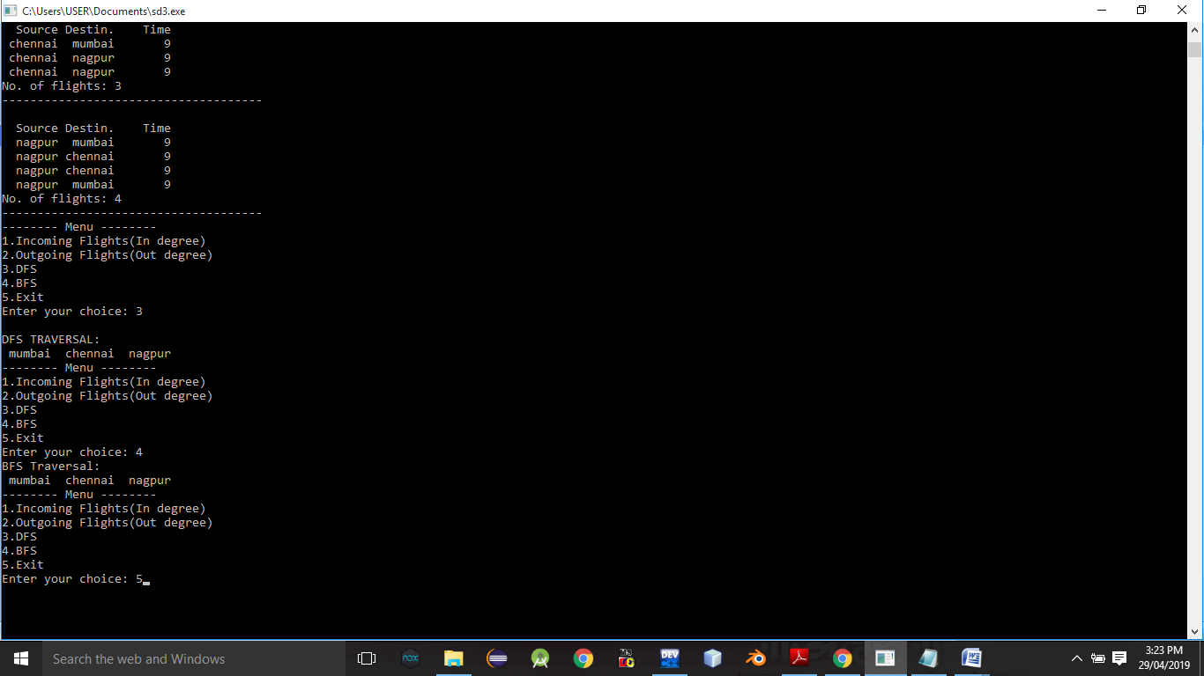

**Conclusion:-** Thus,we have studied adjacency graph representation.

**ASSIGNMENT NO.4.**

**Aim :-** For a weighted graph G, find the minimum spanning tree using Prims algorithm .

**Objective:-** To study the prims algorithm.

**Theory:-**

Prim’s algorithm is also a [Greedy algorithm](https://www.geeksforgeeks.org/archives/18528). It starts with an empty spanning tree. The idea is to maintain two sets of vertices. The first set contains the vertices already included in the MST, the other set contains the vertices not yet included. At every step, it considers all the edges that connect the two sets, and picks the minimum weight edge from these edges. After picking the edge, it moves the other endpoint of the edge to the set containing MST.  
A group of edges that connects two set of vertices in a graph is called [cut in graph theory](http://en.wikipedia.org/wiki/Cut_%28graph_theory%29). So, at every step of Prim’s algorithm, we find a cut (of two sets, one contains the vertices already included in MST and other contains rest of the verices), pick the minimum weight edge from the cut and include this vertex to MST Set (the set that contains already included vertices)

.

**How does Prim’s Algorithm Work?** The idea behind Prim’s algorithm is simple, a spanning tree means all vertices must be connected. So the two disjoint subsets (discussed above) of vertices must be connected to make a Spanning Tree. And they must be connected with the minimum weight edge to make it a Minimum Spanning Tree.

**Algorithm:-**

**1)** Create a set mstSet that keeps track of vertices already included in MST.

**2)** Assign a key value to all vertices in the input graph. Initialize all key values as INFINITE. Assign key value as 0 for the first vertex so that it is picked first.

**3)** While mstSet doesn’t include all vertices  
….**a)** Pick a vertex u which is not there in mstSet and has minimum key value.  
….**b)** Include u to mstSet.  
….**c)** Update key value of all adjacent vertices of u. To update the key values, iterate through all adjacent vertices. For every adjacent vertex v, if weight of edge u-v is less than the previous key value of v, update the key value as weight of u-v

The idea of using key values is to pick the minimum weight edge from [cut](http://en.wikipedia.org/wiki/Cut_(graph_theory)). The key values are used only for vertices which are not yet included in MST, the key value for these vertices indicate the minimum weight edges connecting them to the set of vertices included in MST.

**Program Code:-**

#include<iostream>

#include<conio.h>

#include<stdlib.h>

using namespace std;

int cost[10][10],i,j,k,n,stk[10],top,v,visit[10],visited[10],u;

main()

{

int m,c;

cout <<"enterno of vertices";

cin >> n;

cout <<"ente no of edges";

cin >> m;

cout <<"\nEDGES Cost\n";

for(k=1;k<=m;k++)

{

cin >>i>>j>>c;

cost[i][j]=c;

}

for(i=1;i<=n;i++)

for(j=1;j<=n;j++)

if(cost[i][j]==0)

cost[i][j]=31999;

cout <<"ORDER OF VISITED VERTICES";

k=1;

while(k<n)

{

m=31999;

if(k==1)

{

for(i=1;i<=n;i++)

for(j=1;j<=m;j++)

if(cost[i][j]<m)

{

m=cost[i][j];

u=i;

}

}

else

{

for(j=n;j>=1;j--)

if(cost[v][j]<m && visited[j]!=1 && visit[j]!=1)

{

visit[j]=1;

stk[top]=j;

top++;

m=cost[v][j];

u=j;

}

}

cost[v][u]=31999;

v=u;

cout<<v << " ";

k++;

visit[v]=0; visited[v]=1;

}

}

**Output Screenshots:-**

**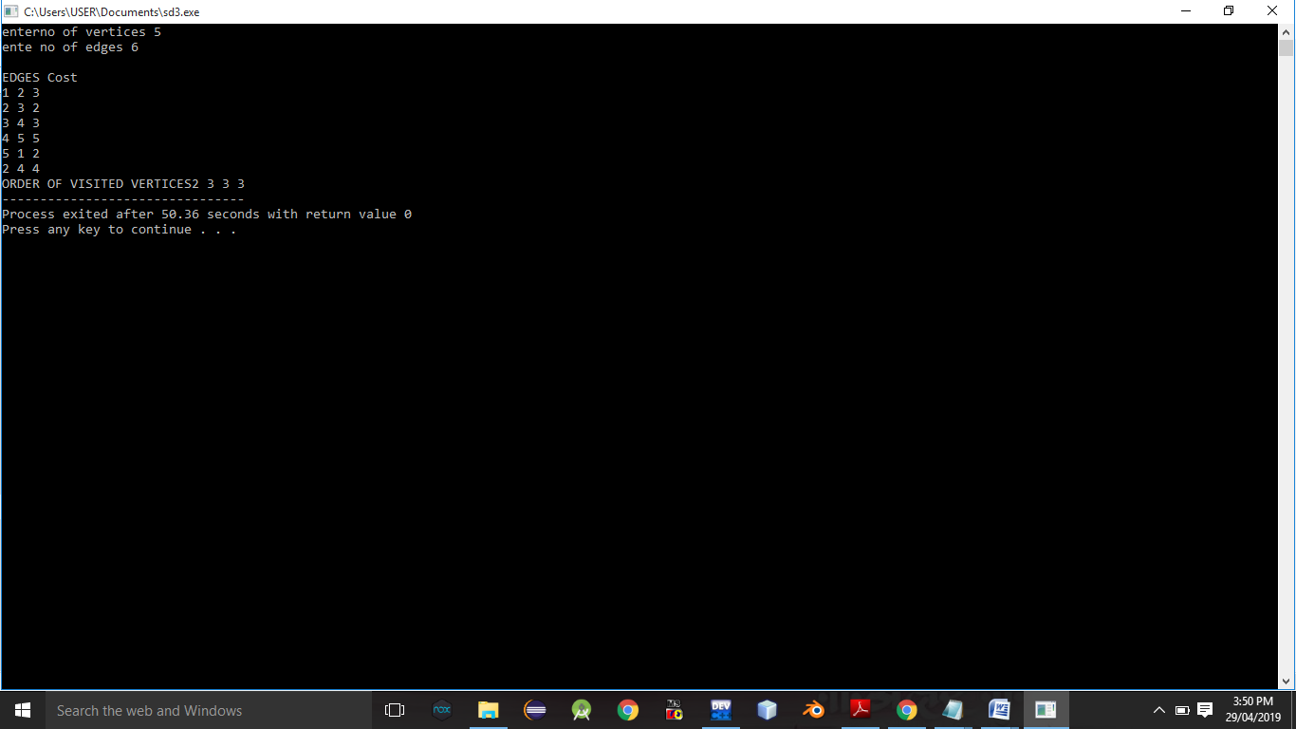**

**Conclusion:-** Thus,we have studied prims algorithm.

**ASSIGNMENT NO.5.**

**Aim :-**

You have a business with several offices; you want to lease phone lines to connect them up with each other; and the phone company charges different amounts of money to connect different pairs of cities. You want a set of lines that connects all your offices with a minimum total cost. Solve the problem by suggesting appropriate data structures .

**Objective:-** To study the use of kruskal’s and prims algorithm in given problem.

**Theory:-** What is Minimum Spanning Tree?  
Given a connected and undirected graph, a spanning tree of that graph is a subgraph that is a tree and connects all the vertices together. A single graph can have many different spanning trees. A minimum spanning tree (MST) or minimum weight spanning tree for a weighted, connected and undirected graph is a spanning tree with weight less than or equal to the weight of every other spanning tree. The weight of a spanning tree is the sum of weights given to each edge of the spanning tree.

How many edges does a minimum spanning tree has?  
A minimum spanning tree has (V – 1) edges where V is the number of vertices in the given graph.

What are the applications of Minimum Spanning Tree?  
See [this](https://www.geeksforgeeks.org/applications-of-minimum-spanning-tree/)for applications of MST.

Below are the steps for finding MST using Kruskal’s algorithm

***1.****Sort all the edges in non-decreasing order of their weight.****2.****Pick the smallest edge. Check if it forms a cycle with the spanning tree formed so far. If cycle is not formed, include this edge. Else, discard it.****3.****Repeat step#2 until there are (V-1) edges in the spanning tree.*

The step#2 uses [Union-Find algorithm](https://www.geeksforgeeks.org/union-find/) to detect cycle.

The algorithm is a Greedy Algorithm. The Greedy Choice is to pick the smallest weight edge that does not cause a cycle in the MST constructed so far.

**Algorithm:-**

* create a forest *F* (a set of trees), where each vertex in the graph is a separate [tree](https://en.wikipedia.org/wiki/Tree_(graph_theory))
* create a set *S* containing all the edges in the graph
* while *S* is [nonempty](https://en.wikipedia.org/wiki/Nonempty) and *F* is not yet [spanning](https://en.wikipedia.org/wiki/Spanning_tree)
  + remove an edge with minimum weight from *S*
  + if the removed edge connects two different trees then add it to the forest *F*, combining two trees into a single tree

At the termination of the algorithm, the forest forms a minimum spanning forest of the graph. If the graph is connected, the forest has a single component and forms a minimum spanning tree.

**Program Code:-**

#include <iostream>

#include<iomanip>

using namespace std;

const int MAX=10;

class EdgeList; //forward declaration

class Edge //USED IN KRUSKAL

{

int u,v,w;

public:

Edge(){} //Empty Constructor

Edge(int a,int b,int weight)

{

u=a;

v=b;

w=weight;

}

friend class EdgeList;

friend class PhoneGraph;

};

//---- EdgeList Class ----------

class EdgeList

{

Edge data[MAX];

int n;

public:

friend class PhoneGraph;

EdgeList()

{ n=0;}

void sort();

void print();

};

//----Bubble Sort for sorting edges in increasing weights' order ---//

void EdgeList::sort()

{

Edge temp;

for(int i=1;i<n;i++)

for(int j=0;j<n-1;j++)

if(data[j].w>data[j+1].w)

{

temp=data[j];

data[j]=data[j+1];

data[j+1]=temp;

}

}

void EdgeList::print()

{

int cost=0;

for(int i=0;i<n;i++)

{

cout<<"\n"<<i+1<<" "<<data[i].u<<"--"<<data[i].v<<" = "<<data[i].w;

cost=cost+data[i].w;

}

cout<<"\nMinimum cost of Telephone Graph = "<<cost;

}

//------------ Phone Graph Class---------------

class PhoneGraph

{

int data[MAX][MAX]={{0, 28, 0, 0, 0,10,0},

{28,0,16,0,0,0,14},

{0,16,0,12,0,0,0},

{0,0,12,0,22,0,18},

{0,0,0,22,0,25,24},

{10,0,0,0,25,0,0},

{0,14,0,18,24,0,0},

};

int n;

public:

PhoneGraph(int num)

{

n=num;

}

void readgraph();

void printGraph();

int mincost(int cost[],bool visited[]);

int prim();

void kruskal(EdgeList &spanlist);

int find(int belongs[], int vertexno);

void unionComp(int belongs[], int c1,int c2);

};

void PhoneGraph::readgraph()

{

cout<<"Enter Adjacency(Cost) Matrix: \n";

for(int i=0;i<n;i++)

{

for(int j=0;j<n; j++)

cin>>data[i][j];

}

}

void PhoneGraph::printGraph()

{

cout<<"\nAdjacency (COST) Matrix: \n";

for(int i=0;i<n;i++)

{

for(int j=0;j<n;j++)

{

cout<<setw(3)<<data[i][j];

}

cout<<endl;

}

}

int PhoneGraph::mincost(int cost[],bool visited[]) //finding vertex with minimum cost

{

int min=9999,min\_index; //initialize min to MAX value(ANY) as temporary

for(int i=0;i<n;i++)

{

if(visited[i]==0 && cost[i]<min)

{

min=cost[i];

min\_index=i;

}

}

return min\_index; //return index of vertex which is not visited and having minimum cost

}

int PhoneGraph::prim()

{

bool visited[MAX];

int parents[MAX]; //storing vertices

int cost[MAX]; //saving minimum cost

for(int i=0;i<n;i++)

{

cost[i]=9999; //set cost as infinity/MAX\_VALUE

visited[i]=0; //initialize visited array to false

}

cost[0]=0; //starting vertex cost

parents[0]=-1; //make first vertex as a root

for(int i=0;i<n-1;i++)

{

int k=mincost(cost,visited); //minimum cost elemets index

visited[k]=1; //set visited

for(int j=0;j<n;j++)//for adjacent verices comparision

{

if(data[k][j] && visited[j]==0 && data[k][j] < cost[j])

{

parents[j]=k;

cost[j]=data[k][j];

}

}

}

cout<<"Minimum Cost Telephone Map:\n";

for(int i=1;i<n;i++)

{

cout<<i<<" -- "<<parents[i]<<" = "<<cost[i]<<endl;

}

int mincost=0;

for (int i = 1; i < n; i++)

mincost+=cost[i]; //data[i][parents[i]];

return mincost;

}

//------- Kruskal's Algorithm

void PhoneGraph::kruskal(EdgeList &spanlist)

{

int belongs[MAX]; //Separate Components at start (No Edges, Only vertices)

int cno1,cno2; //Component 1 & 2

EdgeList elist;

for(int i=1;i<n;i++)

for(int j=0;j<i;j++)

{

if(data[i][j]!=0)

{

elist.data[elist.n]=Edge(i,j,data[i][j]); //constructor for initializing edge

elist.n++;

}

}

elist.sort(); //sorting in increasing weight order

for(int i=0;i<n;i++)

belongs[i]=i;

for(int i=0;i<elist.n;i++)

{

cno1=find(belongs,elist.data[i].u); //find set of u

cno2=find(belongs,elist.data[i].v); ////find set of v

if(cno1!=cno2) //if u & v belongs to different sets

{

spanlist.data[spanlist.n]=elist.data[i]; //ADD Edge to spanlist

spanlist.n=spanlist.n+1;

unionComp(belongs,cno1,cno2); //ADD both components to same set

}

}

}

void PhoneGraph::unionComp(int belongs[],int c1,int c2)

{

for(int i=0;i<n;i++)

{

if(belongs[i]==c2)

belongs[i]=c1;

}

}

int PhoneGraph::find(int belongs[],int vertexno)

{

return belongs[vertexno];

}

//--------- MAIN PROGRAM-----------------------------------

int main() {

int vertices,choice;

EdgeList spantree;

cout<<"Enter Number of cities: ";

cin>>vertices;

PhoneGraph p1(vertices);

//p1.readgraph();

do

{

cout<<"\n1.Find Minimum Total Cost(By Prim's Algorithm)"

<<"\n2.Find Minimum Total Cost(by Kruskal's Algorithms)"

<<"\n3.Re-Read Graph(INPUT)"

<<"\n4.Print Graph"

<<"\n0. Exit"

<<"\nEnter your choice: ";

cin>>choice;

switch(choice)

{

case 1:

cout<<" Minimum cost of Phone Line to cities is: "<<p1.prim();

break;

case 2:

p1.kruskal(spantree);

spantree.print();

break;

case 3:

p1.readgraph();

break;

case 4:

p1.printGraph();

break;

default:

cout<<"\nWrong Choice!!!";

}

}while(choice!=0);

return 0;

}

/\* Sample INPUT: vertices =7

\* {{0, 28, 0, 0, 0,10,0},

{28,0,16,0,0,0,14},

{0,16,0,12,0,0,0},

{0,0,12,0,22,0,18},

{0,0,0,22,0,25,24},

{10,0,0,0,25,0,0},

{0,14,0,18,24,0,0},

};

Minimum Cost: 99

\*/

**Output Screenshots:-**

**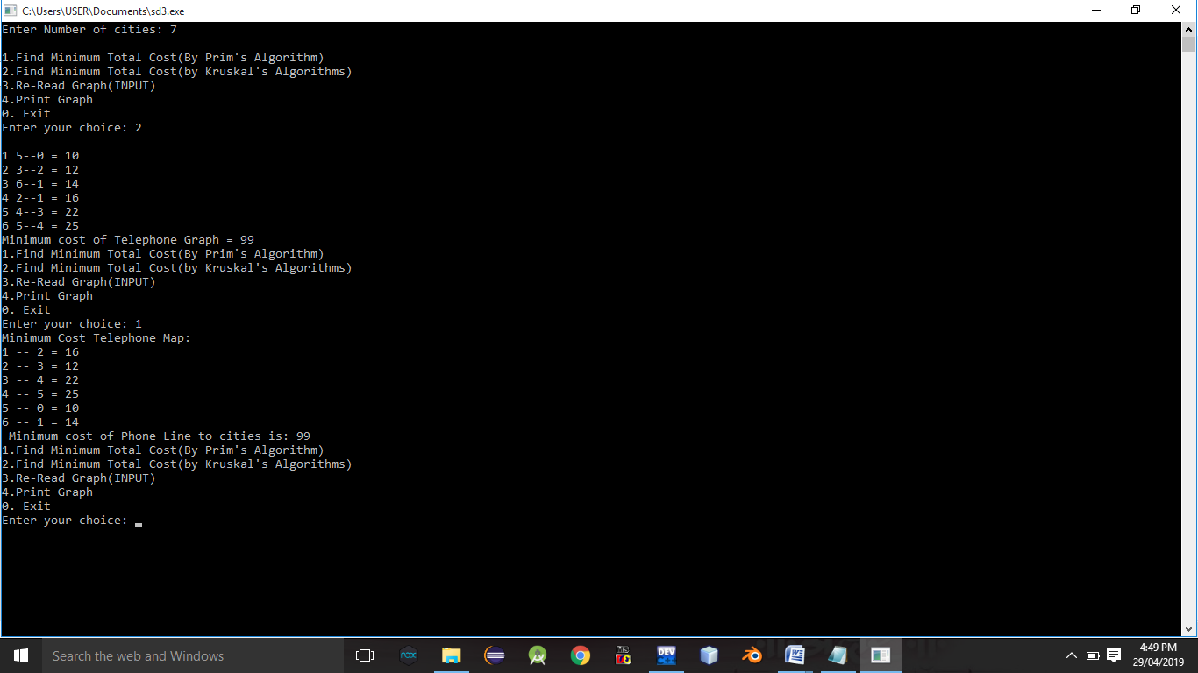**

**Conclusion:-** Thus,we have studied implementation of kruskal’s algorithm.

**ASSIGNMENT NO.6.**

**Aim :-**

Read the marks obtained by students of second year in an online examination of particular subject. Find out maximum and minimum marks obtained in that subject using heap data structure.

**Objective:-** To study the heap data structure.

**Theory:-**

A Heap is a special Tree-based data structure in which the tree is a complete binary tree. Generally, Heaps can be of two types:

1. **Max-Heap**: In a Max-Heap the key present at the root node must be greatest among the keys present at all of it’s children. The same property must be recursively true for all sub-trees in that Binary Tree.
2. **Min-Heap**: In a Min-Heap the key present at the root node must be minimum among the keys present at all of it’s children. The same property must be recursively true for all sub-trees in that Binary Tree.

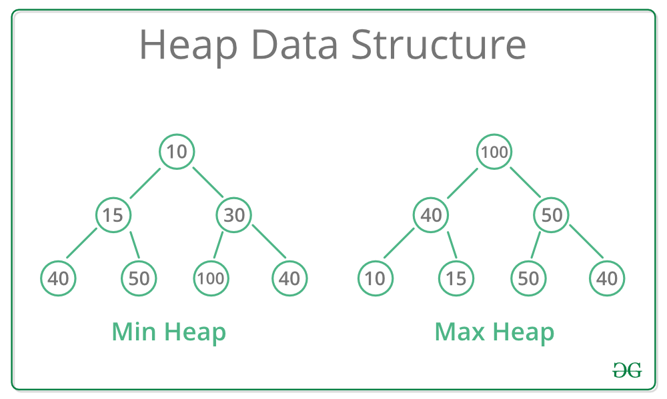

**Applications:-**

1) [Heap Sort](http://quiz.geeksforgeeks.org/heap-sort/): Heap Sort uses Binary Heap to sort an array in O(nLogn) time.

2) Priority Queue: Priority queues can be efficiently implemented using Binary Heap because it supports insert(), delete() and extractmax(), decreaseKey() operations in O(logn) time. Binomoial Heap and Fibonacci Heap are variations of Binary Heap. These variations perform union also efficiently.

3) Graph Algorithms: The priority queues are especially used in Graph Algorithms like [Dijkstra’s Shortest Path](https://www.geeksforgeeks.org/greedy-algorithms-set-7-dijkstras-algorithm-for-adjacency-list-representation/" \t "_blank) and[Prim’s Minimum Spanning Tree](https://www.geeksforgeeks.org/greedy-algorithms-set-5-prims-minimum-spanning-tree-mst-2/" \t "_blank).

4) Many problems can be efficiently solved using Heaps. See following for example.  
a) [K’th Largest Element in an array](https://www.geeksforgeeks.org/k-largestor-smallest-elements-in-an-array/" \t "_blank).  
b) [Sort an almost sorted array/](https://www.geeksforgeeks.org/nearly-sorted-algorithm/" \t "_blank)  
c) [Merge K Sorted Arrays](https://www.geeksforgeeks.org/merge-k-sorted-arrays/" \t "_blank).

**Algorithm:-**

**1.max heap:-**

**Step 1** − Create a new node at the end of heap.

**Step 2** − Assign new value to the node.

**Step 3** − Compare the value of this child node with its parent.

**Step 4** − If value of parent is less than child, then swap them.

**Step 5** − Repeat step 3 & 4 until Heap property holds.

**Program Code:-**

#include<iostream>

using namespace std;

class hp

{

int heap[20],heap1[20],x,n1,i;

public:

hp()

{ heap[0]=0; heap1[0]=0;

}

void getdata();

void insert1(int heap[],int);

void upadjust1(int heap[],int);

void insert2(int heap1[],int);

void upadjust2(int heap1[],int);

void minmax();

};

void hp::getdata()

{

cout<<"\n enter the no. of students";

cin>>n1;

cout<<"\n enter the marks";

for(i=0;i<n1;i++)

{ cin>>x;

insert1(heap,x);

insert2(heap1,x);

}

}

void hp::insert1(int heap[20],int x)

{

int n;

n=heap[0];

heap[n+1]=x;

heap[0]=n+1;

upadjust1(heap,n+1);

}

void hp::upadjust1(int heap[20],int i)

{

int temp;

while(i>1&&heap[i]>heap[i/2])

{

temp=heap[i];

heap[i]=heap[i/2];

heap[i/2]=temp;

i=i/2;

}

}

void hp::insert2(int heap1[20],int x)

{

int n;

n=heap1[0];

heap1[n+1]=x;

heap1[0]=n+1;

upadjust2(heap1,n+1);

}

void hp::upadjust2(int heap1[20],int i)

{

int temp1;

while(i>1&&heap1[i]<heap1[i/2])

{

temp1=heap1[i];

heap1[i]=heap1[i/2];

heap1[i/2]=temp1;

i=i/2;

}

}

void hp::minmax()

{

cout<<"\n max marks"<<heap[1];

cout<<"\n##";

for(i=0;i<=n1;i++)

{ cout<<"\n"<<heap[i]; }

cout<<"\n min marks"<<heap1[1];

cout<<"\n##";

for(i=0;i<=n1;i++)

{ cout<<"\n"<<heap1[i]; }

}

int main()

{

hp h;

h.getdata();

h.minmax();

return 0;

}

**Output Screenshots:-**

**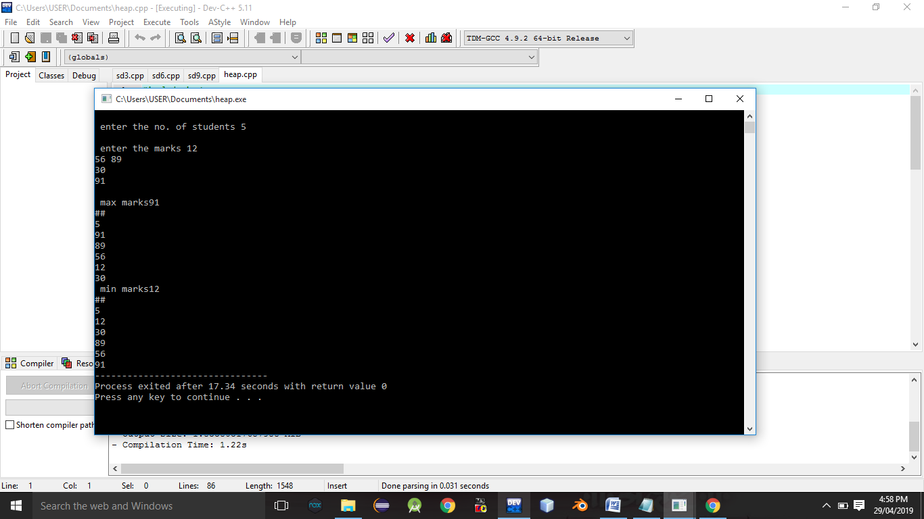**

**Conclusion:-** Thus,we have studied heap data structure,

**ASSIGNMENT NO.7.**

**Aim :-** Insert the keys into a hash table of length m using open addressing using double hashing with h(k)=1+(k mod(m-1)).

**Objective:-** to study the hashing concept and its techniques.

**Theory:-**

**Open Addressing—**

Like separate chaining, open addressing is a method for handling collisions. In Open Addressing, all elements are stored in the hash table itself. So at any point, size of the table must be greater than or equal to the total number of keys (Note that we can increase table size by copying old data if needed).

Insert(k): Keep probing until an empty slot is found. Once an empty slot is found, insert k.

Search(k): Keep probing until slot’s key doesn’t become equal to k or an empty slot is reached.

Delete(k): ***Delete operation is interesting***. If we simply delete a key, then search may fail. So slots of deleted keys are marked specially as “deleted”.  
Insert can insert an item in a deleted slot, but the search doesn’t stop at a deleted slot.

Open Addressing is done following ways:

***a) Linear Probing:*** In linear probing, we linearly probe for next slot. For example, typical gap between two probes is 1 as taken in below example also.  
let **hash(x)** be the slot index computed using hash function and **S** be the table size

If slot hash(x) % S is full, then we try (hash(x) + 1) % S

If (hash(x) + 1) % S is also full, then we try (hash(x) + 2) % S

If (hash(x) + 2) % S is also full, then we try (hash(x) + 3) % S

**Double Hashing:-**

**Double hashing** is a collision resolving technique in [**Open Addressed** Hash tables](https://www.geeksforgeeks.org/hashing-set-3-open-addressing/). Double hashing uses the idea of applying a second hash function to key when a collision occurs.

*Double hashing can be done using :****(hash1(key) + i \* hash2(key)) % TABLE\_SIZE*** *Here hash1() and hash2() are hash functions and TABLE\_SIZE  
is size of hash table.  
(We repeat by increasing i when collision occurs)*

First hash function is typically hash1(key) = key % TABLE\_SIZE

A popular second hash function is : **hash2(key) = PRIME – (key % PRIME)** where PRIME is a prime smaller than the TABLE\_SIZE.

A good second Hash function is:

* It must never evaluate to zero
* Must make sure that all cells can be probed

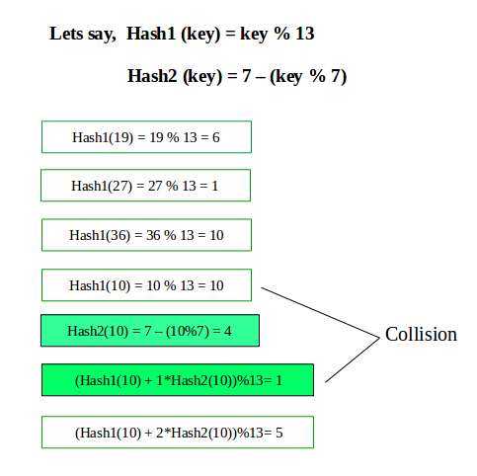

**Algorithm:-**

**Program Code:-**

#include <bits/stdc++.h>

using namespace std;

#define TABLE\_SIZE 13

#define PRIME 7

class DoubleHash

{

int \*hashTable;

int curr\_size;

public:

bool isFull()

{

return (curr\_size == TABLE\_SIZE);

}

int hash1(int key)

{

return (key % TABLE\_SIZE);

}

int hash2(int key)

{

return (PRIME - (key % PRIME));

}

DoubleHash()

{

hashTable = new int[TABLE\_SIZE];

curr\_size = 0;

for (int i=0; i<TABLE\_SIZE; i++)

hashTable[i] = -1;

}

void insertHash(int key)

{

if (isFull())

return;

int index = hash1(key);

if (hashTable[index] != -1)

{

int index2 = hash2(key);

int i = 1;

while (1)

{

int newIndex = (index + i \* index2) %

TABLE\_SIZE;

if (hashTable[newIndex] == -1)

{

hashTable[newIndex] = key;

break;

}

i++;

}

}

else

hashTable[index] = key;

curr\_size++;

}

// function to display the hash table

void displayHash()

{

for (int i = 0; i < TABLE\_SIZE; i++)

{

if (hashTable[i] != -1)

cout << i << " --> "

<< hashTable[i] << endl;

else

cout << i << endl;

}

}

};

// Driver's code

int main()

{

int a[] = {19, 27, 36, 10, 64};

int n = sizeof(a)/sizeof(a[0]);

cout<<"inserted elements in hash table are as follows:";

// inserting keys into hash table

DoubleHash h;

for (int i = 0; i < n; i++)

h.insertHash(a[i]);

// display the hash Table

h.displayHash();

return 0;

}

**Output Screenshots:-**

**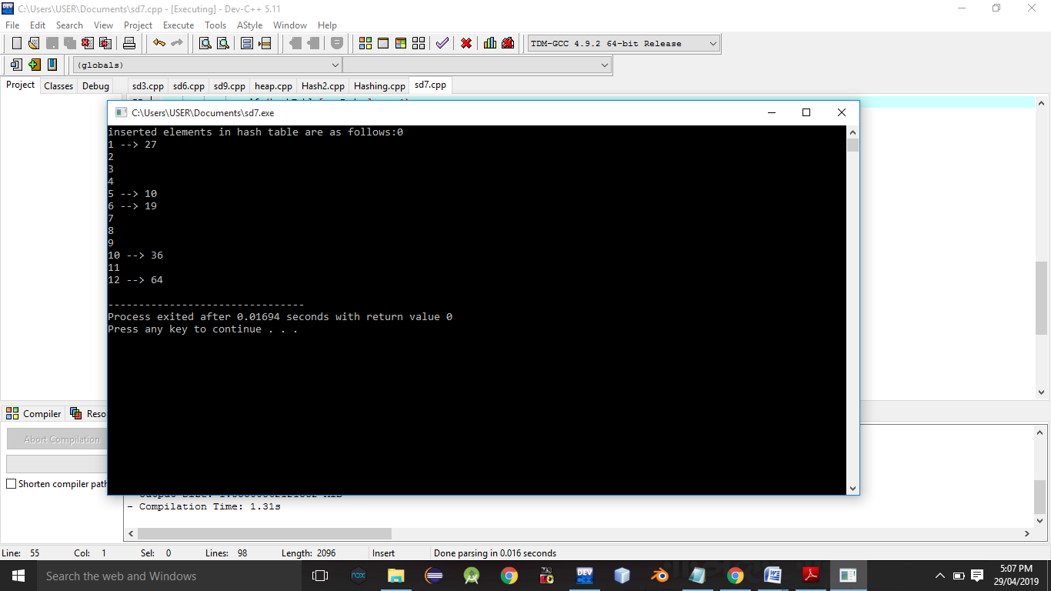**

**Conclusion:-** Thus,we have studied double hashing and hashing technique.

**ASSIGNMENT NO.8.**

**Aim :-** Department maintains a student information. The file contains roll number, name, division and address. Allow user to add, delete information of student. Display information of particular employee. If record of student does not exist an appropriate message is displayed. If it is, then the system displays the student

**Objective:-** To study the different data structure concepts to implement this program.

**Theory:-**

**Input/output formatting**

Writing to or reading from a file is similar to writing onto a terminal screen or reading from a keyboard. Differences are:

* File must be opened with an OPEN statement, in which the unit number and (optionally) the filename are given
* Subsequent writes (or reads) must refer to a known unit number (used for open)
* File should be closed at the end

**File opening and closing**

The syntax is:

OPEN([unit=]lunit,file='name' [,options])

CLOSE([unit=]lunit [,options])

For example:

OPEN(10, file='output.dat', status='new')

CLOSE(unit=10)

* The first parameter is the unit number and the keyword unit= can be omitted.
* The unit numbers 0,5 and 6 are predefined.
  + 0 is output for standard (system) error messages
  + 5 is for standard (user) input
  + 6 is for standard (user) output
  + These units are opened by default and should not be re-opened nor closed by users

Some options for opening a file:

* + status: existence of the file ('old', 'new', 'replace', 'scratch', 'unknown')
  + position: offset, where to start writing ('append')
  + action: file operation mode ('write','read','readwrite')
  + form: text or binary file ('formatted', 'unformatted')
  + access: direct or sequential file access ('direct','sequential','stream')
  + iostat: error indicator, (output) integer (non zero only upon an error)
  + err: the label number to jump upon error
  + recl: record length, (input) integer for direct access files only. Be careful, it can be in bytes or words...

**Algorithm:-**

1. Take the count of number of students from the user

2. Make an array of object of the student class which stores the information of the students

3. Open a file by using the ofstream object

4. Take the information of the student from the user and write it to the file

5. User can perform 1.Search 2.Delete 3.Display operations

***6. For Search***

1.Input the Roll number to be searched

2. Open the file using Ifstream object in input mode

3. Read the contents of the file in an object sequentially and check it with the roll number to be searched if found Display found message and the details of the students

4. If not found continue till end of file

5. If eof is reached display the message Not found

***7.For Delete***

1.Input the roll number to be deleted

2. Open the Main file in input mode and a temporary file in output mode

3.Sequentially search through the main file and copy the contents to the temp file except the roll number to be deleted

4. Delete the contents of the Main file

5. Rename the temp file with the name of the main file

***8. For Display***

1. Open the file in input mode and display the details of all the students sequentially

**Program Code:-**

#include <iostream>

#include <fstream>

#include <cstring>

#include <iomanip>

#include<cstdlib>

#define max 50

using namespace std;

class Student

{

char name[max];

int rollNo;

int year;

int division;

char address[50];

friend class FileOperations;

public: Student()

{

strcpy(name,"");

rollNo=year=division=0;

strcpy(address,"");

}

Student(char name[max],int rollNo,int year,int division,char address[max])

{

strcpy(this->address,address);

strcpy(this->name,name);

this->division=division;

this->rollNo=rollNo;

this->year=year;

}

int getRollNo()

{

return rollNo;

}

void displayStudentData()

{

cout<<endl<<setw(3)<<rollNo<<setw(10)<<name<<setw(3)<<year<<setw(2)<<division<<setw(10)<<address;

}

};

class FileOperations

{

fstream file;

public:FileOperations(char \*name)

{

//strcpy(this->name,name);

this->file.open(name,ios::in|ios::out|ios::ate|ios::binary);

}

void insertRecord(int rollNo,char name[max],int year,int division,char address[max])

{

Student s=Student(name,rollNo,year,division,address);

file.seekp(0,ios::end);

file.write((char\*)&s,sizeof(Student));

file.clear();

}

void displayAllRecords()

{

Student s;

file.seekg(0,ios::beg);

while(file.read((char \*)&s,sizeof(Student)))

{

s.displayStudentData();

}

file.clear();

}

void displayRecord(int rollNo)

{

Student s;

file.seekg(0,ios::beg);

void \*p;

while(file.read((char \*)&s,sizeof(Student)))

{

if(s.rollNo==rollNo)

{

s.displayStudentData();

break;

}

}

if(p==NULL)

throw "Element not present";

file.clear();

}

void deleteRecord(int rollNo)

{

ofstream newFile("new.txt",ios::binary);

file.seekg(0,ios::beg);

bool flag=false;

Student s;

while(file.read((char \*)&s,sizeof(s)))

{

if(s.rollNo==rollNo)

{

flag=true;

continue;

}

newFile.write((char \*)&s,sizeof(s));

}

if(!flag)

{

cout<<"Element Not Present";

}

file.close();

newFile.close();

remove("student.txt");

rename("new.txt","student.txt");

file.open("student.txt",ios::in|ios::ate|ios::out|ios::binary);

}

~FileOperations()

{

file.close();

cout<<"Closing file..";

}

};

int main()

{

ofstream newFile("student.txt",ios::app|ios::binary);

newFile.close();

FileOperations file((char \*)"student.txt");

int rollNo,year,choice=0;

char division;

char name[max],address[max];

while(choice!=5)

{

//clrscr();

cout<<"\n\*\*\*\*\*Phone Book\*\*\*\*\*\n";

cout<<"1) Add New Record\n";

cout<<"2) Display All Records\n";

cout<<"3) Display by RollNo\n";

cout<<"4) Deleting a Record\n";

cout<<"5) Exit\n";

cout<<"Choose your choice : ";

cin>>choice;

switch(choice)

{

case 1 : //New Record

cout<<endl<<"Enter RollNo and name : \n";

cin>>rollNo>>name;

cout<<"Enter Year and Division : \n";

cin>>year>>division;

cout<<"Enter address : \n";

cin>>address;

file.insertRecord(rollNo,name,year,division,address);

break;

case 2 :

file.displayAllRecords();

break;

case 3 :

cout<<"Enter Roll Number";

cin>>rollNo;

try

{

file.displayRecord(rollNo);

}

catch(const char \*str)

{

cout<<str;

}

break;

case 4:

cout<<"Enter rollNo";

cin>>rollNo;

file.deleteRecord(rollNo);

break;

case 5 :break;

}

}

}

**Output Screenshots:-**

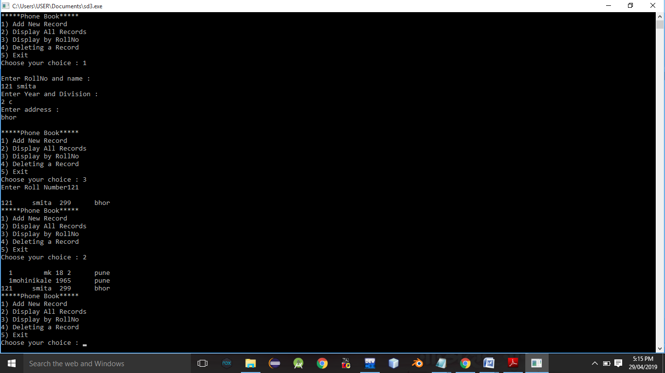

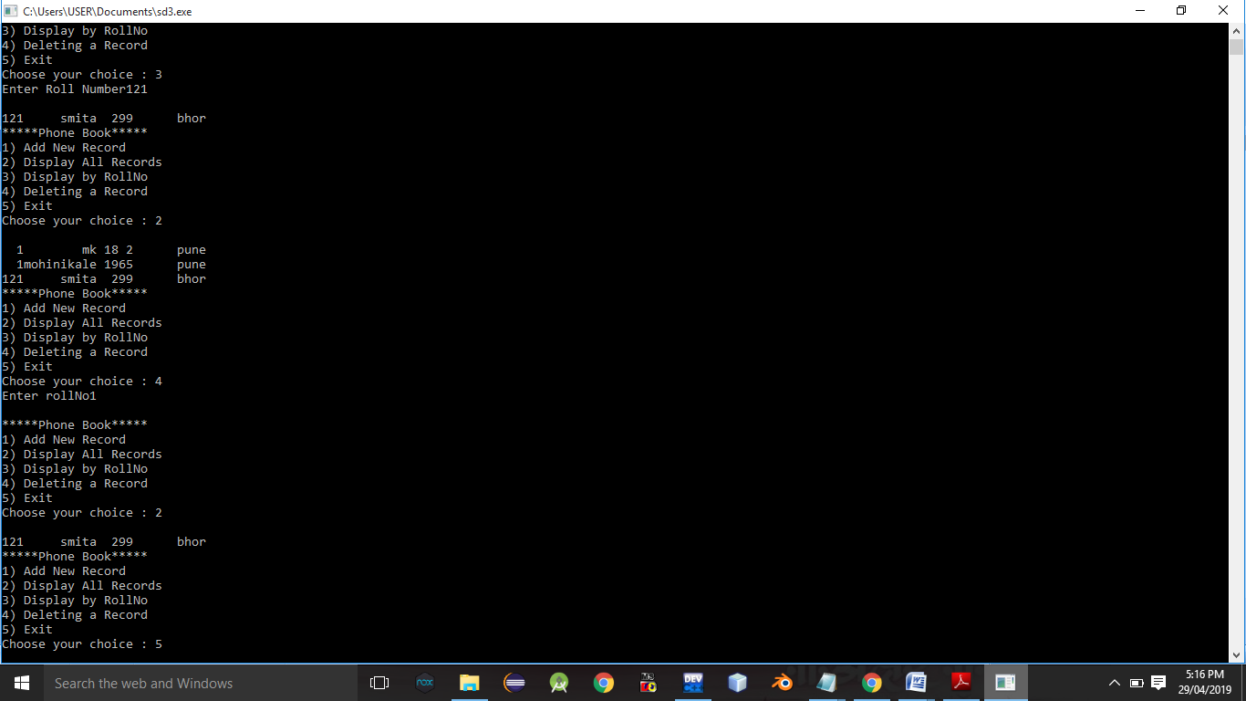

**Conclusion:-** Thus,this assignment implemented successfully.

**ASSIGNMENT NO.9.**

**Aim :-** Company maintains employee information as employee ID, name, designation and salary. Allow user to add, delete information of employee. Display information of particular employee. If employee does not exist an appropriate message is displayed. If it is, then the system displays the employee details. Use index sequential file to maintain the data.

**Objective:-** to study use of different data structure concepts in this program.

**Theory:-**

**Input/output formatting**

Writing to or reading from a file is similar to writing onto a terminal screen or reading from a keyboard. Differences are:

* File must be opened with an OPEN statement, in which the unit number and (optionally) the filename are given
* Subsequent writes (or reads) must refer to a known unit number (used for open)
* File should be closed at the end

**File opening and closing**

The syntax is:

OPEN([unit=]lunit,file='name' [,options])

CLOSE([unit=]lunit [,options])

For example:

OPEN(10, file='output.dat', status='new')

CLOSE(unit=10)

* The first parameter is the unit number and the keyword unit= can be omitted.
* The unit numbers 0,5 and 6 are predefined.
  + 0 is output for standard (system) error messages
  + 5 is for standard (user) input
  + 6 is for standard (user) output
  + These units are opened by default and should not be re-opened nor closed by users

Some options for opening a file:

* + status: existence of the file ('old', 'new', 'replace', 'scratch', 'unknown')
  + position: offset, where to start writing ('append')
  + action: file operation mode ('write','read','readwrite')
  + form: text or binary file ('formatted', 'unformatted')
  + access: direct or sequential file access ('direct','sequential','stream')
  + iostat: error indicator, (output) integer (non zero only upon an error)
  + err: the label number to jump upon error
  + recl: record length, (input) integer for direct access files only. Be careful, it can be in bytes or words...

**Algorithm:-**

**Program Code:-**

#include <iostream>

#include <fstream>

#include <cstring>

#include <iomanip>

#include<cstdlib>

#define max 50

using namespace std;

class Employee

{

char name[max];

int empid;

int sal;

char de[50];

friend class FileOperations;

public: Employee()

{

strcpy(name,"");

empid=sal==0;

strcpy(de,"");

}

Employee(char name[max],int empid,int sal,char de[max])

{

strcpy(this->de,de);

strcpy(this->name,name);

this->empid=empid;

this->sal=sal;

}

int getEmpId()

{

return empid;

}

void displayEmployeeData()

{

cout<<endl<<empid<<"\t\t\t"<<name<<"\t\t\t"<<sal<<"\t\t\t"<<de;

}

};

class FileOperations

{

fstream file;

public:FileOperations(char \*name)

{

//strcpy(this->name,name);

this->file.open(name,ios::in|ios::out|ios::ate|ios::binary);

}

void insertRecord(int empid,char name[max],int sal,char de[max])

{

Employee s=Employee(name,empid,sal,de);

file.seekp(0,ios::end);

file.write((char\*)&s,sizeof(Employee));

file.clear();

}

void displayAllRecords()

{

Employee s;

file.seekg(0,ios::beg);

while(file.read((char \*)&s,sizeof(Employee)))

{

s.displayEmployeeData();

}

file.clear();

}

void displayRecord(int empid)

{

Employee s;

file.seekg(0,ios::beg);

void \*p;

while(file.read((char \*)&s,sizeof(Employee)))

{

if(s.empid==empid)

{

s.displayEmployeeData();

break;

}

}

if(p==NULL)

throw "Element not present";

file.clear();

}

void deleteRecord(int empid)

{

ofstream newFile("new.txt",ios::binary);

file.seekg(0,ios::beg);

bool flag=false;

Employee s;

while(file.read((char \*)&s,sizeof(s)))

{

if(s.empid==empid)

{

flag=true;

continue;

}

newFile.write((char \*)&s,sizeof(s));

}

if(!flag)

{

cout<<"Element Not Present";

}

file.close();

newFile.close();

remove("Employee.txt");

rename("new.txt","Employee.txt");

file.open("Employee.txt",ios::in|ios::ate|ios::out|ios::binary);

}

~FileOperations()

{

file.close();

cout<<"Closing file..";

}

};

int main()

{

ofstream newFile("Employee.txt",ios::app|ios::binary);

newFile.close();

FileOperations file((char \*)"Employee.txt");

int empid,sal,choice=0;

char name[max],de[max];

while(choice!=5)

{

cout<<"\n\n1) Add New Record\n";

cout<<"2) Display All Records\n";

cout<<"3) Display by RollNo\n";

cout<<"4) Deleting a Record\n";

cout<<"5) Exit\n";

cout<<"Choose your choice : ";

cin>>choice;

switch(choice)

{

case 1 : //New Record

cout<<endl<<"Enter employee id and name : \n";

cin>>empid>>name;

cout<<"Enter sal \n";

cin>>sal;

cout<<"Enter designation : \n";

cin>>de;

file.insertRecord(empid,name,sal,de);

break;

case 2 :

cout<<"Employee ID"<<"\t\t"<<"Name"<<"\t\t"<<"Salary"<<"\t\t"<<"designation\n";

cout<<"----------------------------------------------------------------------";

file.displayAllRecords();

break;

case 3 :

cout<<"Enter employee id";

cin>>empid;

try

{

file.displayRecord(empid);

}

catch(const char \*str)

{

cout<<str;

}

break;

case 4:

cout<<"Enter employe id";

cin>>empid;

file.deleteRecord(empid);

break;

case 5 :break;

}

}

}

**Output Screenshots:-**

**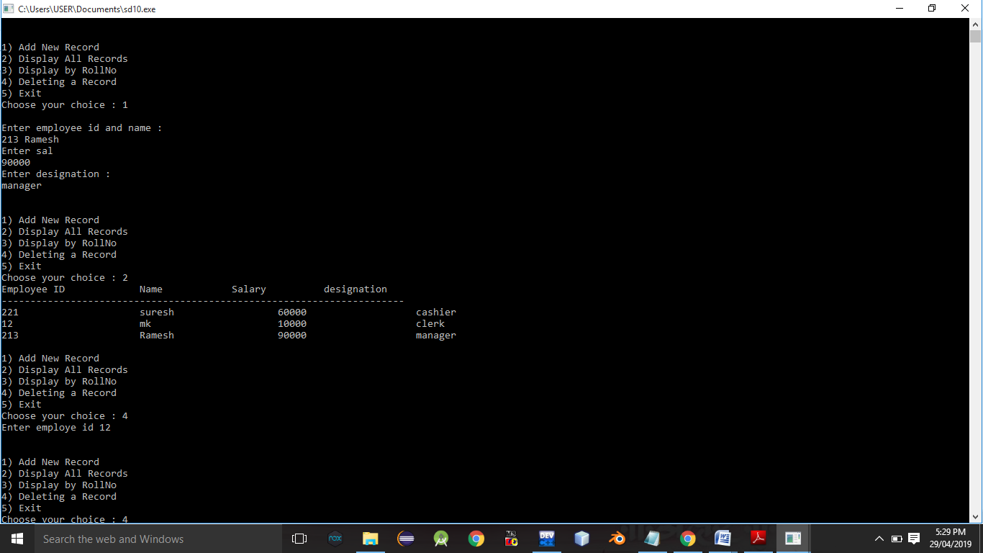**

**Conclusion:-** Thus, this assignment is completed successfully.